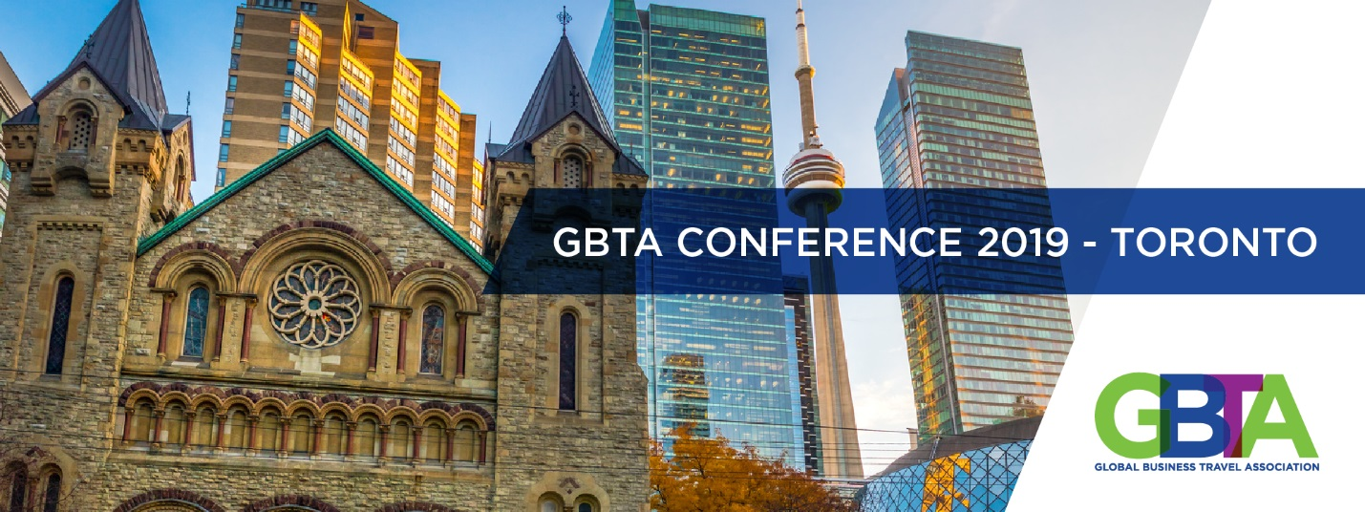
TO:
FROM:
SUBJECT: Proposal to attend GBTA Conference 2019 - Toronto
I would like to participate in GBTA Conference 2019 - Toronto - an education-focused conference in Toronto at which over 800 corporate travel purchasing and meetings management professionals will be attending.
The conference content will address issues that we face daily and teach us how we could implement improvements and achieve optimal outcomes within our company. It will also educate on the latest best practise, typically with buyer case studies making it easier to see how these learnings can be applied in real-life situations. Sessions are delivered by leading industry experts as well as business professionals from industries outside travel that impact global corporate travel.
The event is also an opportunity for me to network with other business travel professionals who face the same challenges we face every day, share experiences, and benefit from their insights. While the expo component allows me to meet with many suppliers in a time efficient manner to find out about their latest developments that could benefit our travel programme.
I believe that by attending this conference I will be able to:
- Enter Goal 1
- Enter Goal 2
- Enter Goal 3

Here is an approximate breakdown of costs associated with my attendance:
Three-Day Conference  *This includes all education sessions and meals. | $
Accommodations estimate | $
Flight estimate | $
Professional Development Course (pre-conference) | $
Total | $

I will of course submit a summary report and share trends in best practices and strategies I have learned with the staff upon my return. Please see this link to the conference agenda and descriptions of the education sessions: http://canadaconference.gbta.org/
Thank you for your consideration.
Sincerely,

